Compilers

Principle ,Techniques, and Tools
Anbar University – Computer College

Intermediate Code Generation ( IR)

IR is an internal form of a program created by the compiler while translating the program from a H.L.L to L.L.L.(assembly or machine code),from IR the back end of compiler generates target code.

Although a source program can be translated directly into the target language,some benefits of using a machine independent IR are:
  - A compiler for different machine can be created by attaching a back end for a new machine into an existing front end.
  - Certain optimization strategies can be more easily performed on IR than on either original program or L.L.L.

  - An IR represents a more attractive form of target code.

Intermediate Languages:-

- Syntax Tree and Postfix Notation are tow kinds of intermediate representations, for example a=b*-c+b*-c

 |  | = |  |  |  |  |  | =
a |  |  |  | + |  |  |  | a |  | +
 |  | * |  |  |  | * |  |  |  | *
b |  | - |  |  | b | - |  | b |  | -
 |  |  | c |  |  |  | c |  |  |  |  |  |  |  | c
 | Syntax Tree |  |  |  |  |  |  |  |  |  | DAG

- A DAG give the same information in syntax tree but in compact way because common subexpressions are identified.

- Postfix notation is a linearized representation of a syntax tree, for example: a b c - * b c - * + =

- Two representation of above syntax tree are:

With My Best Wishes 44 Esam

 |  |  |  |  | Compilers |  |  |  |  |  |  |  |  | Anbar University – Computer College
 | Principle ,Techniques, and Tools
 |  |  |  |  |  |  |  |  |  |  |  |  |  | 0 |  | id | b
 |  |  |  | = |  | • |  |  | •
 |  |  |  |  |  |  |  |  |  |  |  |  |  | 1 |  | id | c
 |  |  |  |  | id |  | a |  |  |  |  |  |  | 2 |  | - | 1
 |  |  |  |  |  |  |  |  |  |  |  |  |  | 3 |  | * | 0 | 2
 |  |  |  | + |  | • |  | • |  |  |  |  |  | 4 |  | id | b
 |  |  |  |  |  |  |  |  |  |  |  |  |  | 5
 |  |  |  |  |  |  |  |  |  |  |  |  |  |  |  | id | c
 |  |  |  |  |  |  |  |  |  |  |  |  |  | 6 |  | - | 5
 |  |  |  |  |  |  |  |  |  |  |  |  |  |  | 7 | * | 4 | 6
* | • |  |  |  | • |  |  |  |  | * | • |  | •
 |  |  |  |  |  |  |  |  |  |  |  |  |  |  | 8 | + | 3 | 7
 |  |  |  |  |  |  |  |  |  |  |  |  |  | 9 |  | id | a
id |  | b |  |  |  |  |  |  |  | id |  | b
 |  |  |  |  |  |  |  |  |  |  |  |  |  | 10 |  | = | 9 | 8
 |  |  |  |  |  |  |  |  |  |  |  |  |  |  |  | …. | ….. | …..
- | • |  |  |  |  |  |  |  |  | - | •
 |  |  |  |  |  |  |  |  |  |  |  |  |  |  |  | ….. | ….. | …..
id |  |  | c |  |  |  |  |  |  | id |  | c
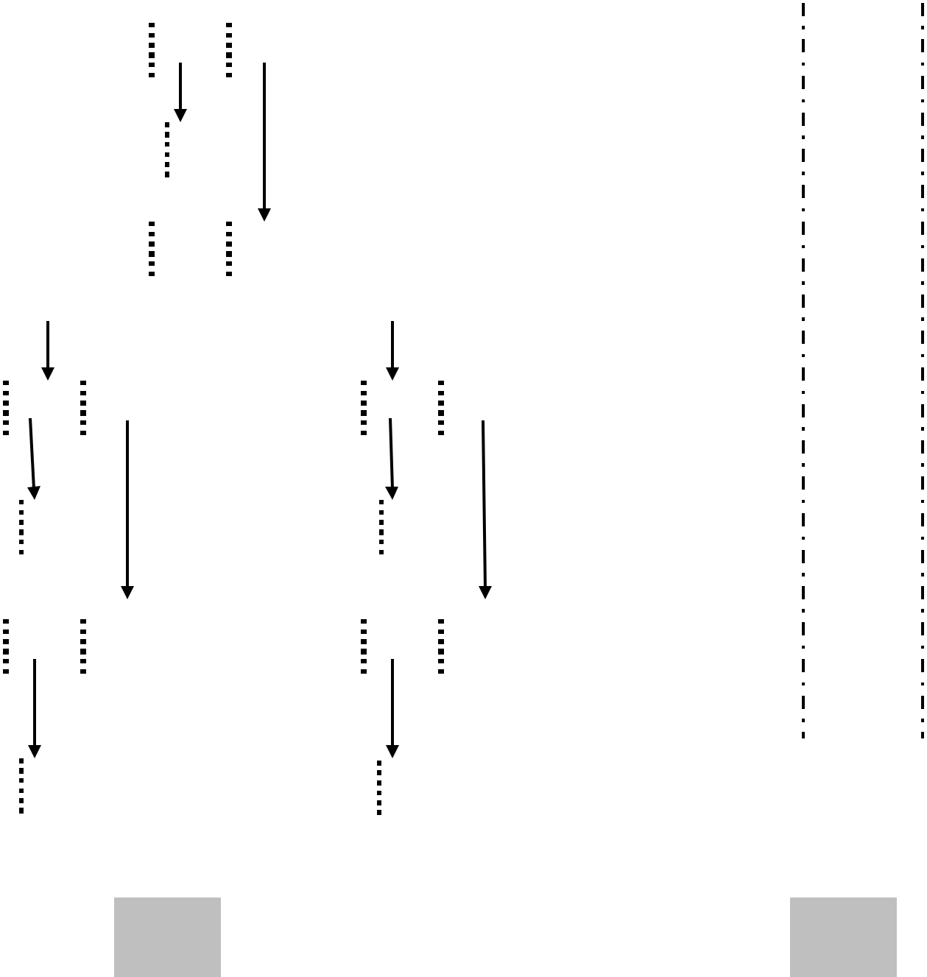

1 2

- Three-Address Code is a sequence of statements of the general form :

X=Y op Z // op is binary arithmetic

operation

For example : x + y * z

t1 = y * z

t2 = x + t1

where t1 ,t2 are compiler generated temporary.

With My Best Wishes 45 Esam

Compilers

Principle ,Techniques, and Tools
Anbar University – Computer College

Types of three address code statement:-

- Assignment statements of the form X=Y op Z ( where op is a binary arithmetic or logical operator).

- Assignment instructions of the form X= op Y ( op is a unary operator).

- Copy statements of the form X=Y .

- Unconditional jump ( Goto L ).

- Conditional jump ( if X relop Y goto L).

- Param X & Call P,N for procedure call and and return Y , for example :

Param x1 Param x2
……..
Param xn

Call P,n
- Index assignments of the form X=Y[i] & X[i]=Y.

- Address & Pointer Assignments

X= &Y
X= * Y

*X= Y

Example : a= b * -c + b * -c

t1 |  | = - c |  |  | t1 |  | = - c
t2 |  | = b * t1 |  |  | t2 |  | = b * t1
t3 |  | = - c |  |  | t5 |  | = t2 + t2
t4 |  | = b * t3 |  |  | a = t5
t5 |  | = t2 + t4
a = t5
 |  | Three address code |  |  |  |  | Three address code
 |  | For syntax tree |  |  |  |  | For DAG

With My Best Wishes 46 Esam

Compilers

Principle ,Techniques, and Tools
Anbar University – Computer College

Note: Three-address statements are a kin to assembly code statements can have symbolic labels and there are statements for flow of control.

Implementation of Three Address Code :-

In compiler , three-address code can be implement as records, with fields for operator and operands.

- Quadruples :- It is a record structure with four fields:

  - OP // operator

  - arg1 , arg2 // operands
  - result

- Triples :- To avoid entering temporary into ST , we might refer to a temporary value by position of the statement that compute it . So three address can be represent by record with only three fields:

  - OP // operator

  - arg1 , arg2 // operands

With My Best Wishes 47 Esam

 | Compilers |  |  |  | Anbar University – Computer College
 | Principle ,Techniques, and Tools
 | Example: a = b * -c + b * -c
 |  | i. By Quadruples
 | Position | OP |  | arg1 |  | arg2 | result
 | 0 | - |  | c |  |  | t1
 | 1 | * |  | b |  | t1 | t2
 | 2 | - |  | c |  |  | t3
 | 3 | * |  | b |  | t3 | t4
 | 4 | + |  | t2 |  | t4 | t5
 | 5 | = |  | t5 |  |  | a

 | ii. | By Triples
 | Position |  |  | OP | arg1 | arg2
 | 0 |  |  | - | c
 | 1 |  |  | * | b | (0)
 | 2 |  |  | - | c
 | 3 |  |  | * | b | (2)
 | 4 |  |  | + | (1) | (3)
 | 5 |  |  | = | a | (4)

With My Best Wishes 48 Esam

