**CROWN AND BRIDGE**

Lecture (**3**) Third class 

**Finishing line of the preparation (F.L.):** It’s the final margin that separates between the prepared and the unprepared tooth structure. The finishing line should be smoothly continuous from one surface to the other, because it will interfere with seating of the crown if it’s poorly done.

**Types of finishing line (f.l.):**

**[1] Feather edge f.l. :**

We use pointed end tapered fissure bur to provide this type of margin.

It’s the most conservative type of f.l. i.e. the least amount of tooth structure is removed. But the margin is weak.

It’s easy to prepare but difficult to be detected on the cast or tooth, the gold can be burnished to this margin.

**It’s mainly used for**:

**1- Full Metal Crown (All the surface).**

**2- Lingual and proximal surfaces of full veneer crown, three quarter crown and post crown**.

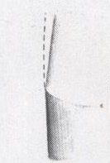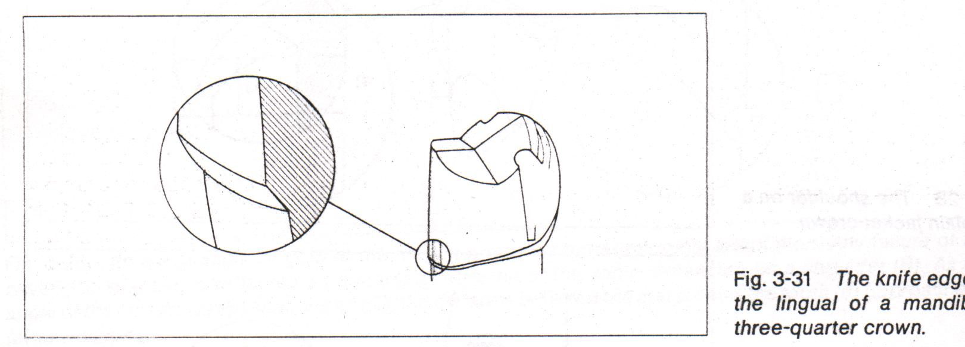

**[2] Chamfer f.l.:**

It is well defined f.l. That has an adequate space in the cervical region so we can make the contour of the crown restoration within the contour of natural tooth.

It is thick, difficult to obtain and the gold margin is unburnishable, it is mainly used for:

**1- Full Metal Crown (All the surfaces).**

**2- Lingual and proximal surfaces of full veneer crown, three quarter crown and post crown**.

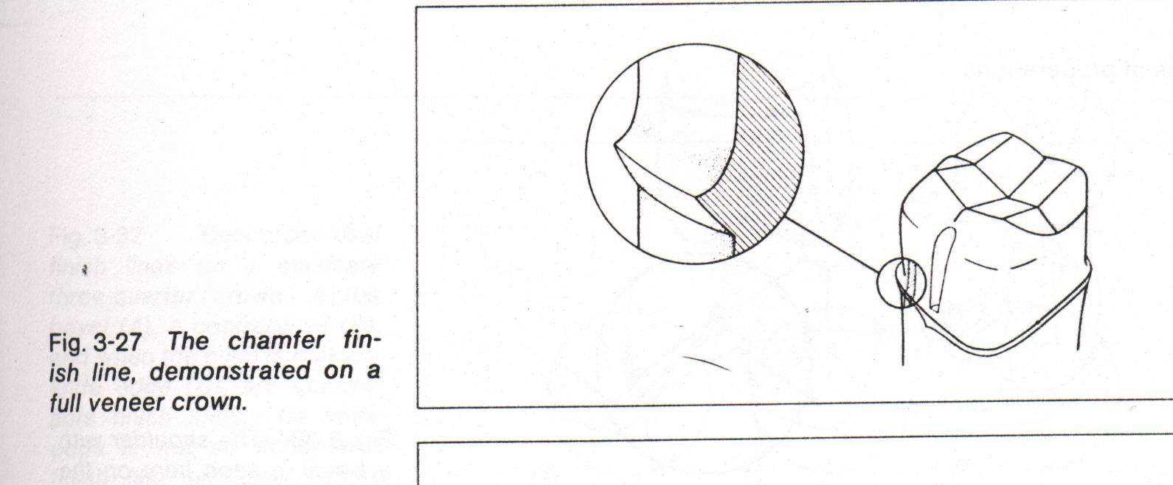

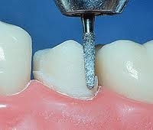**.**

**[3] Shoulder f.l. (butt shoulder)**

It’s the least conservative type of f.l. because we need excessive amount of tooth structure to be removed to prepare the tooth.

Shoulder f.l. is almost used with jacket (all around) since jacket is made either of porcelain or acrylic resin (brittle materials) that require enough thickness which is necessary to withstand the force of occlusion without fracture, also this thickness provides better shade of the material and so better esthetics

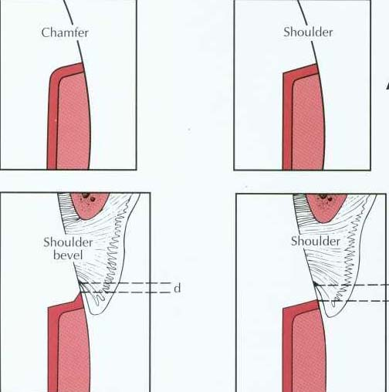

**[4] Bevel shoulder f.l.**

By creating a bevel on the end margin of unprepared tooth structure, this is needed when we use a metal with facing material e.g. Metal- porcelain or metal-acrylic.

The bevel provides a burnishable margin for the metal that may extend subgingivally, and we use it when esthetic is highly needed e.g. anterior teeth. (Labial surface of Full veneer crown only).

It needs enough space for shape and contour for esthetic reason, the margin is made up of metal. (The thinner it is the more adaptable to the tooth surface).

We used gold alloy because ceramic materials when extended subgingivally are irritant to the gingiva.

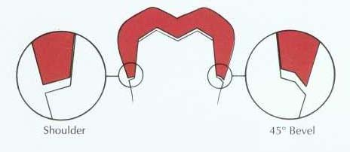.

**Bevel shoulder is used on the labial surface of full veneer crown and is recommended for extremely short walls.**

**Margin placement:**

Finishing line can be placed either:

**\*Subgingival:**

Placing the margin below the gingival tissue for these reasons:-

a- For esthetic reason.

b- To increase retention of short teeth.

c- To place the margin on sound tooth structure.

**\*Supragingival:**

Placing the margin above the gingival tissue for these reasons:-

**a-** It’s self cleansable area.

**b-** To provide good vision for the dentist during preparation.

**c-** Easy to finished.

**d-** Easy to take impression

**e-** Less destructive

**\* Placing the margin within the level of the gingiva.**

**Principles of tooth preparation:**

**1-**Preservation of the tooth structure:

the preparation of the tooth must be conservative, the minimal amount of the tooth structure must be removed , excessive amount of the tooth structure in addition to be destructive phenomenon it has many harmful effects:-

**A**-Excessive reduction lead to thermal hypersensitivity, pulpal inflammation and necrosis may result from approaching to the pulp closely.

**B-**The tooth might be over tapered or shortened and this might affect the retention and resistance of the prepared tooth**.**

**2- Retention and resistance form:**

**Retention:** is the ability of the preparation to resist the crown restoration from removal along its path of insertion.

**Resistance:** is the ability of the preparation to resist the dislodgment of the restoration by forces directed obliquely or horizontally to the restoration.

**Path of insertion :** An imaginary line along which the restoration can be inserted and removed without causing lateral force on the abutment.

The crown restoration should have a single path of insertion to be retentive .

Most of the time the path of insertion is parallel to the long axis of the tooth,

when posterior teeth are prepared to receive a full metal crown or ¾ crown, while in the anterior teeth ¾ crown it is parallel to the incisal 2/3 (not to the long axis)

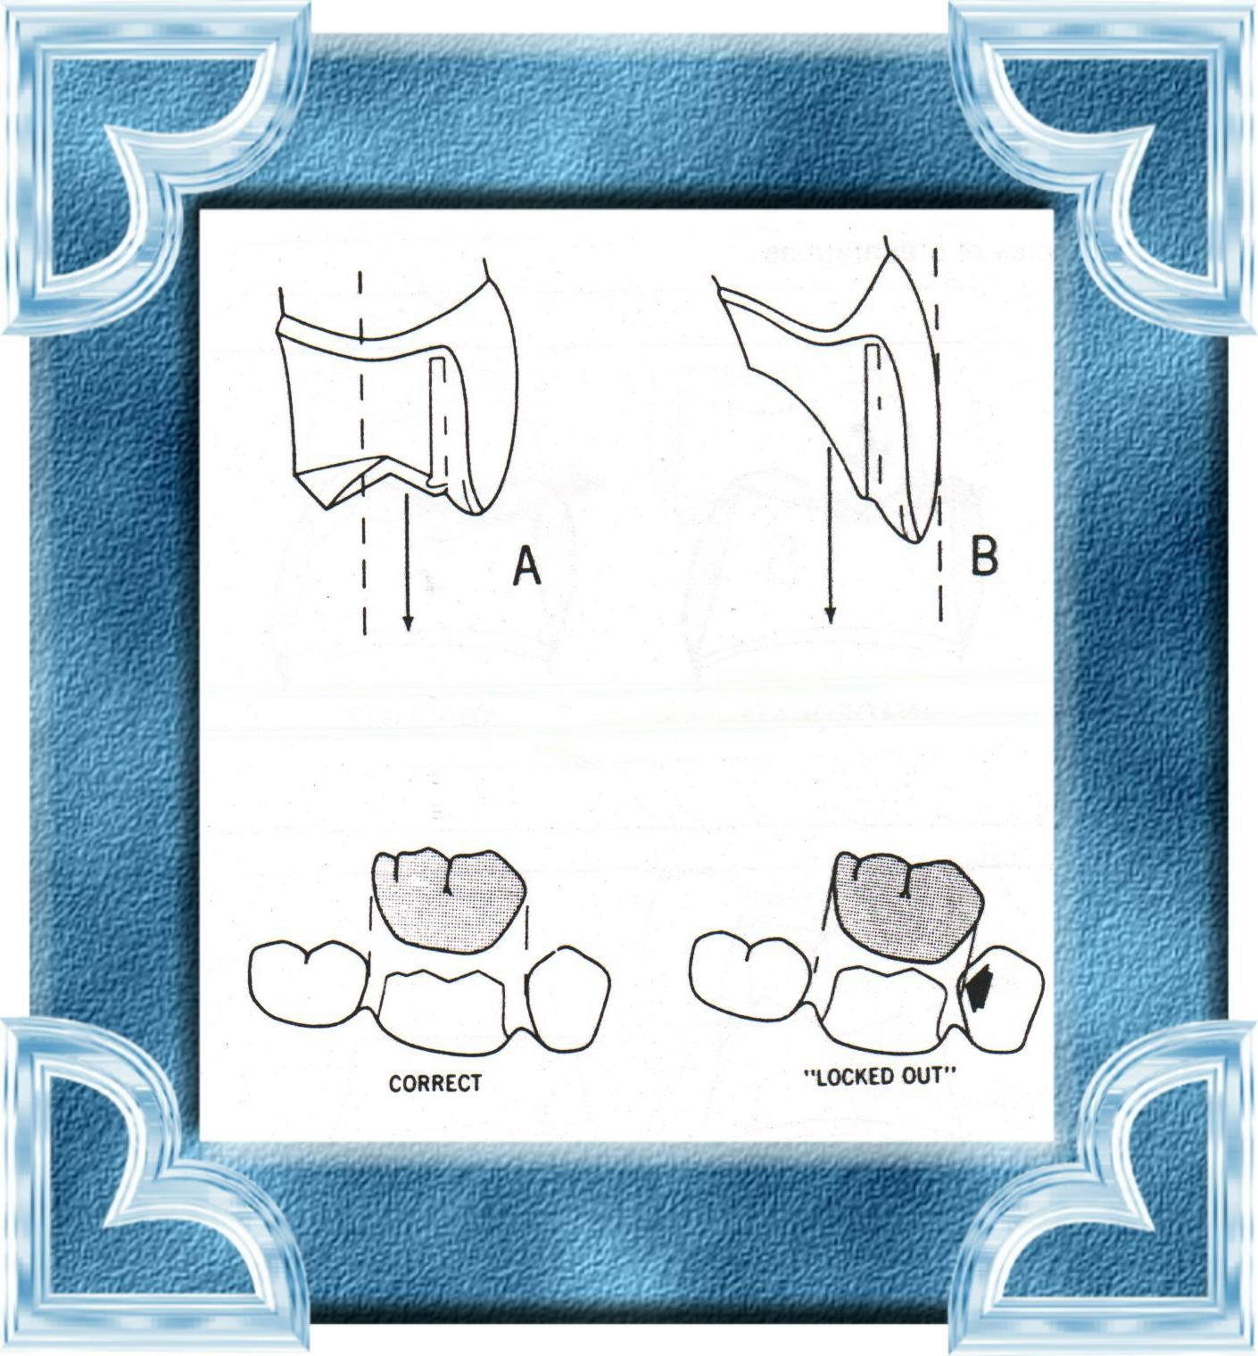

**Factors affecting retention and resistance:**

**1-** Taper of the preparation (most important factor). The more the parallel wall the more the retention. But parallel wall is difficult to be obtained in the patient mouth without undercuts so we do tapering.

**The convergence angle:** is the angle that determines the convergence of the prepared tooth.

The magnitude of retention depends on the degree of this angle. The greater the taper the less the retention.

*(5-6) degree convergence angle is the mostly used to provide the needed retention.

**2-** Surface area of the preparation (increasing the surface area increase retention).

**3-** Length area of the preparation and height. Increasing the length increase retention.

**4-** Extra retention means.

**Resistance form** of Full metal crown and three quarter crown. The buccoaxial wall of a complete crown should provide good resistance to rotation around a lingual axis. and in a 3/4 crown, resistance must be done by mesial and distal grooves. While in a short or excessively tapered complete crown, resistance form is minimal because most of the buccal wall is missing, a mesiodistal groove should be placed to increase resistance form. and poor resistance form is less a problem in a short partial crown because of presence of mesial and distal grooves.

**3- Structural Durability:**

The preparation must be designed so that it will be possible to have an adequate bulk of metal to allow the restoration to withstand the forces of occlusion, and allow proper contouring and carving of anatomy in the restoration.

Preparation features related to st. du.: -

1- Occlusal reduction.

2- Axial reduction**.**

**Occlusal clearance:** is the distance (space) between the occlusal surface of the prepared tooth and that of apposing tooth.

It should be evaluated in centric and eccentric relation.

It should follow the same tooth anatomy this will provide adequate clearance without excessive tooth reduction. A flat occlusal preparation will result in either **(1) insufficient clearance or (2) an excessive amount of reduction**.



**Functional cusps:** the cusps that give centric stops of occlusion. (Palatal of upper posterior teeth and buccal of lower posterior teeth).

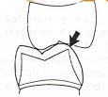

**4.Marginal Integrity:-**

**the restoration margin should:**

**a-**They must fit as closelyas possible against the finishing line of preparation.

**b-**They must be sufficient strength.

**c-** Whenever possible they should be placed in an area where the dentist can finish them properly and the patient clean them properly.

**5. Preservation of periodontal tissue:-**

**1-** Whenever possible the margin of the preparation should be supragingival.

**2-** The casting should have proper contact, embrasure form, occlusion and a healthy occluso-gingival contour.