**CROWN AND BRIDGE**

Lecture (4) Third class 

**Full metal crown**

It is one of the most commonly used crowns .It can be used as a single unit or as a retainer for a bridge. It has better retention and resistance to displacement than other partial coverage crowns as 3/4 crown because all the axial walls are Included as well as the occlusal surface ,therefore this type of crown is used to cover a small abutment teeth , and in cases of long edentulous area.

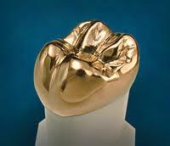

**Indications of full metal crown**

**1.**Teeth with extensive caries, large amalgam restorations in order to protect the remaining tooth structure and amalgam from fracture.

**2-** Teeth where maximum retention and resistance is needed as short crowns.

**3-** As a bridge retainer.

**4-** Recontouring of the tooth.

**5-** Teeth receiving clasps for partial denture.

**Contra-Indications**

**1-** If high esthetic need is demanded.

**2-** If a more conservative crown could be used,ex:3/4 crown . As intact buccal surface.

**3-** When caries index is low.

**Steps in preparation**

**Depth Orientation groove.(D.O.G.)**

This is a groove that is placed on a surface of a tooth to act as a guide or reference to determine when sufficient amount of tooth structure is removed by preparation, if preparation is done without these grooves under and over preparation is possible, and more time will be wasted by repeated checking of the preparation.

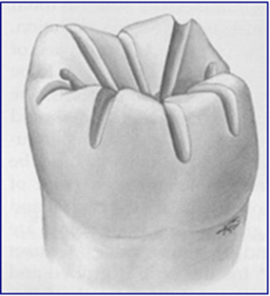

**Occlusal surface preparation**

-Depth orientation grooves (D.O.G.) are made on the occlusal surface by a fissure bur to follow the inclines of the cusps.

-Join the grooves by preparing the lingual half of the occlusal surface and then the buccal half.

-The occlusal preparation in the functional cusps should be 1.5mm, and at least 1mm for the nonfunctional cusps.

-The occlusal clearance should be kept in all occlusal movements (centric, eccentric, protrusive movements).

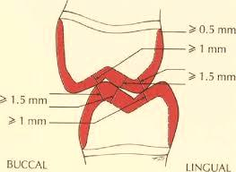

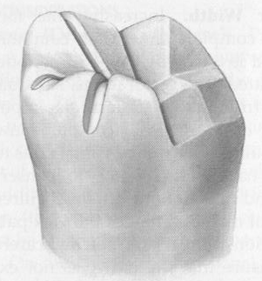

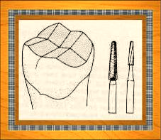

**Buccal surface preparation**

Three D.O.Gs are placed in the buccal surface, mesially, middle and distally by a narrow round end fissure bur so that all the bur is embedded in the tooth structure and the long axis of the bur is parallel with long axis of the tooth.

-Join the grooves by the same bur and leave the tip of the bur in the gingival area to make a continuous, smooth chamfer finishing line.

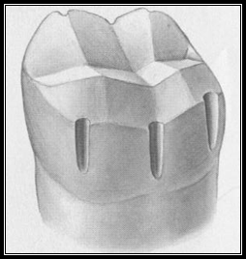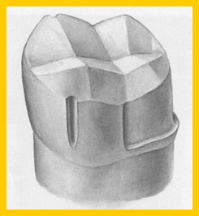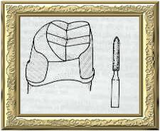

**Proximal surface preparation**

By the use of a fine tapered fissure bur, the contact area should be removed carefully by moving buccolingually.

The bur should rest on the prepared tooth to prevent any damage to the adjacent tooth, which if it is damaged will cause a rough surface susceptible for future caries.

**Finishing the preparation**

Any sharp end should be removed because this will act as a stress concentration area. Finish all prepared surfaced and slightly round all line angles.

Smooth transitions from occlusal to axial surfaces facilitate impression making, waxing, investing, and casting because bubble formation is reduced.

Use a fine-grit diamond or carbide bur of slightly greater diameter for finishing the chamfer margin. The wider diamond is recommended because it will smooth out any unwanted ripples that may have been created during axial reducing and will eliminate any unsupported enamel at the margin.Place a functional cusp bevel at this time.



A seating groove is placed in the buccal surface of the lower molar and the palatal surface of the upper molar which acts as a guide during the placement of the crown and prevents the rotation.

