**CROWN AND BRIDGE**

Lecture (5) Third class 

**Full metal crown with facing**

**(full veneer crown)**

**It is a full metal crown having:**

* the labial or buccal surface covered by a tooth colored material (acrylic or porcelain).

*It combines the strength of full metal and the cosmetic effect of the tooth colored material.

*It can be used on the anterior and posterior teeth.

*It is not a conservative type of crown because it includes excessive tooth preparation to provide enough space for the metal and the facing material.

**Indications:-**

**1-** Improvement of esthetic(carious teeth, malposed teeth, peg shaped lateral incisor, colored teeth).

**2-** Fractured tooth.

**3-** Teeth with large filling.

**4-** As a bridge retainer especially in long span bridge.

**5-** On endodontically treated teeth with sufficient tooth structure.

**Contra-indications:-**

**1-**Teeth with large pulp (because of possibilityof pulp exposure during preparation).

**2-**Teeth with short crowns.

**3-**Patient with bad oral hygiene.

**4-** Cannot accommodate a rest for removable partial denture.

**Preparation of full metal crown with facing on posterior teeth**

The same principle of preparation of the full metal crown should be followed except for the buccal preparation where it should be deeper than that for the full metal crown preparation, this is important to provide enough space for the metal and the facing material, and to get a proper shade of the final crown.The finishing line should be beveled shoulder on the labial surface and chamfer on the other surfaces.

**Preparation of full metal crown with facing on anterior teeth**

**1-Incisal reduction**.

Place three depth grooves (1.8mm deep) in the incisal edge of an anterior tooth. This will provide the needed reduction of 2mm and allow finishing.

The completed reduction of the incisal edge on an anterior tooth should allow 2 mm for adequate material thickness to permit translucency in the completed restoration.

Incisal (Occlusal) reduction should be done first to allow easy instrument access to the axial surfaces and the gingival finish line.

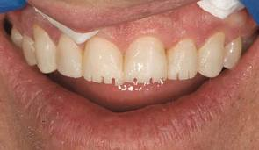

**2-Labial reduction**.

Preparation of the labial surface is divided into 2parts:

**a) Cervical (Gingival) portion**

A (D.O.G.)of 1 mm. depth is placed in the gingival parallel to the long axis of the tooth, and by moving the bur with the inclination, this portion will be prepared. This will determined the path of insertion of completed restoration

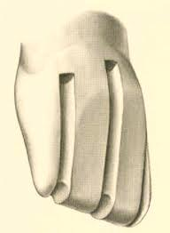

**b)Incisal portion**

The (D.O.G.) should be placed parallel to the inclination of this area, or follow the normal facial contour . this will provide the space needed for the porcelain veneer if the incisor's portion's preparation is not done in this way pulp exposure is possible.

The finishing line should be beveled shoulder so that the bevel is going to be under the gingiva to hide the beveled metal portion of the crown. The facial shoulder should extend at least 1mm lingual to the proximal contact, to ensure esthetics.

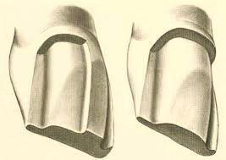

**3-Facial reduction.**

The reduction of the facial surface should have produced sufficient space to accommodate the metal substructure and porcelain veneer.

A minimum of 1.2 mm is necessary to permit the ceramist to produce a restoration with satisfactory appearance (1.5 mm is preferable).

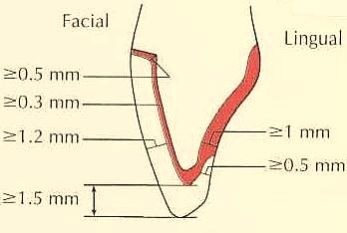

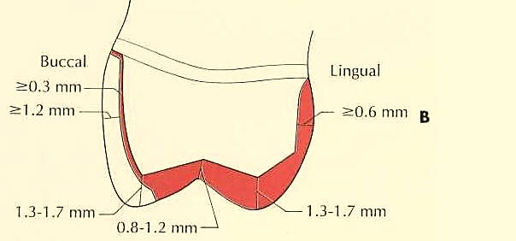

**3-Lingual reduction.**

**The lingual surface is divided to:-**

**a)Cingulum portion.**

A (D.O.G.) of 0.5 mm. depth is placed parallel to the long axis of the tooth in the center of the cingulum, and by moving the bur mesially and distally the area will be reduced and produced smooth chamfer **.**

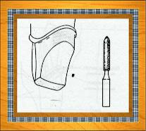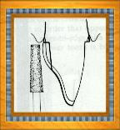

**b)Lingual fossa portion.**

The remaining lingual surface should be reduced using a wheel diamond bur, the junction between the lingual fossa and the cingulum portion should be preserved to increase retention and resistance by increasing the surface area.

Finally the line angles should be smoothened and rounded to facilitate the steps of crown construction.

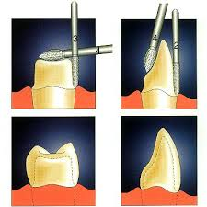

For molars, three grooves can be placed similar to that described for the complete cast crown.

As the lingual chamfer is developed, extend it buccally into the proximal to join with the interproximal shoulder placed earlier, a lingual chamfer is prepared to allow adequate space for metal.

The margin should follow the soft tissue contour.

**4- Proximal reduction.**

Preparation of the proximal surfaces is done in the same manner as in the full metal crown preparation. The finishing line for the proximal and lingual surfaces should be chamfer and above the gingival line.

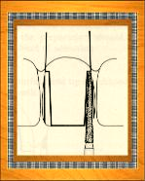

**Evaluation:**

**\***Avoid creating an undercut between the facial and lingual walls.

*Excessive convergence should be avoided, because this may lead to pulp exposure.

*Avoid any unsupported tooth structure at the shoulder and chamfer finish line.

*The completed chamfer should provide 0.5 mm of space for the restoration at the margin.

*The chamfer should be continuous with the interproximal shoulder.



**Preparation of (F.V.C.) on canines**

The same steps of preparation of (F.V.C.) on incisors are followed for canines with only two exceptions which are:-

**1-** For the cusp area the (D.O.G.) should be placed at the tip of the cusp and by moving the bur mesially and distally along the slopes of the cusp this area will be reduced.

**2-** For the palatal or lingual surface, the final preparation should preserve the lingual anatomy of the lingual ridge and 2 lingual fossae.

