**CROWN AND BRIDGE**

Lecture (6) Third class 

**Three quarter crown**

It is a cast gold restoration which covers 3/4 of the crown (occlusal or incisal,lingual, and proximal surfaces) leaving the labial or buccal surface unprepared. It is less retentive and less resistant to displacement compared to full metal and full veneer crown.

The resistance to lateral force or buccolingual displacement of the restoration is prevented by internal feature (e.g. proximal boxes and grooves).

**Uses:**

**1-**As a retainer for short span bridge.

**2-**As a single restoration.

**3-**As a splint in anterior teeth.

**Indications:**

**1-** On teeth with clinical crown of good length and thickness labiolingually.

**2-** Patient with good oral hygiene.

**3-** On teeth with or without minimal caries on buccal or labial surface.

**4-** No discrepancy between axial relationship of tooth and path of insertion of a bridge.

**Contraindications:**

**1-** Short teeth.

**2-** Poor oral hygiene.

**3-** Narrow proximal surfaces.

**4-** Tooth with extensive caries.

**5-** Long span bridge.

**6-** Non vital teeth.

**Advantages of 3/4 crown:**

**1-** Tooth structure is saved

**2-** Better esthetic than other types of crowns

**3-** Vitality test can be done on the unprepared tooth surface

**4-** Less chance of periodontal irritation because all the margins of the crown is supragingival

**5-** Complete seating of the crown can be easily seen by direct observation.

**Disadvantages:**

**1-** Difficulty in preparation compared to other types of crowns.

**2-** There is more possibility of recurrent caries along the cavosurface line angle.

**3-** There is a possibility of showing metal especially in the lower anterior and posterior teeth

**Occlusal Reduction.**

Initial depth holes are placed in the mesial and distal fossae approximately 0.8mm deep. Three guiding grooves in each cusp and for functional cusp for bevel similar to that of complete cast crown. The exception in the groove that placed in the lingual incline of the buccal cusp. It becomes shallower as they approach the buccal cusp tip.

Upon the completion of occlusal reduction, a clearance of at least 1.5 mm should exist on the centric cusp and at least 1.0 mm on the noncentric cusp and in the central groove.

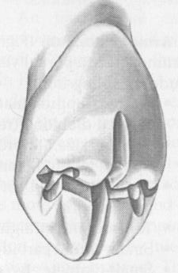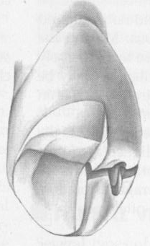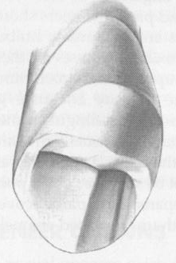



**Axial Reduction:-**

Three alignment grooves should be parallel to the long axis of the tooth and should not exceed half the width of the tip of the diamond used to place them. Remove tooth structure between the grooves and place a cervical chamfer.

Carry the diamond into the proximal embrasure and reduce the proximal wall. Stop the proximal reduction slightly short of breaking the proximal contact. The resulting flange should be parallel to the linguoaxial preparation, with the chamfer placed sufficiently cervical to provide at least 0.6 mm of clearance with the adjacent tooth and the axial wall allowing for a proximal groove of at least 4mm of length occluso-cervically.

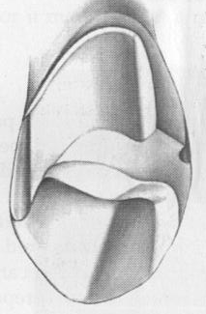

**Groove Placement:-**

Preparation of the proximal groove is best done with a tapered carbide bur.

Position the bur against the interproximal flange parallel to the long axis and perpendicular to the axial surface.

Enter full depth of the bur, the groove need not to be deeper than 1mm at its cervical end but may be deeper near its occlusal end. This is because of the tapering of the carbide bur.



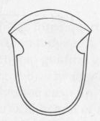

**Criteria of the Proximal Groove:-**

The groove should resist lingual displacement of an explorer, the lingual walls of the proximal groove should have 90-degree angle, to resist lingual displacement.

The walls of the grooves should not be undercut relative to the long axis of the tooth.

The walls should be flared toward the intact buccal surface of the tooth. The aim of flaring is removing any unsupported tooth structure remain at the cavosurface angle of the buccal surface.

**Bucco-occlusal contrabevel:-**

It is a narrow contrabevel that connects the mesial and distal flares **Purpose: -** To remove any unsupported enamel and protect the buccal cusp tip from chipping during function.

**Criteria: -** The bevel should remain within the curvature of the cusp tip rather than extend onto the buccal wall, Thus the restoration will be less obvious.

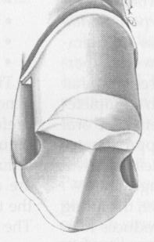

**Preparation of 3/4 crown on**

**anterior teeth**

**lingual surface**: this is done by two steps similar to other types of crowns.

**1-** cingulum portion.

**2-** lingual fossa portion.

**Incisal reduction :**

For the maxillary anterior teeth a lingual-incisal bevel is placed using a diamond bur at 35˚to the lingual surface, this preparation should not be extended labially to prevent showing of gold, for the lower anterior teeth, a reverse bevel is placed on the labial surface to cover the incisal edge in order to protect the area of unsupported enamel from fracture and prevent the dislodgement of the crown.

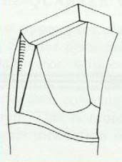

**Proximal reduction:**

The area is prepared similar to the full metal and full veneer crown but care should be taken to avoid the break of the contact to the labial surface.

Two proximal grooves should be placed parallel to the incisal 2/3 of the labial surface using a carbide fissure bur to get the longest groove for better retention and to avoid overcutting to the labial surface resulting in poor esthetic.

The grooves should be placed at the junction of the labial and middle third of the proximal surface and parallel to each other.

The base of the groove should be 0.5 mm. above the chamfer finishing line.

The mesial and distal grooves should be connected with an incisal offset.

The advantage of the incisal offset is the improvement of the strength of casting at this area and reinforcement of margin by connecting the two proximal grooves together.

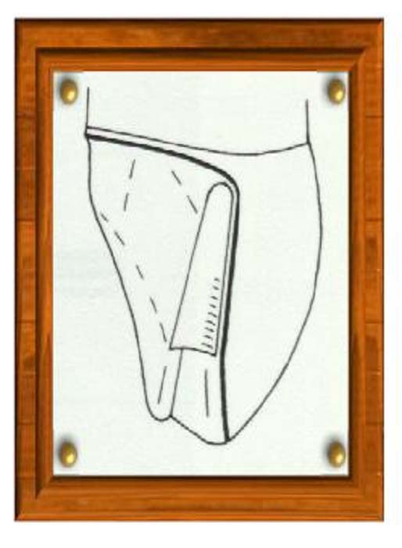 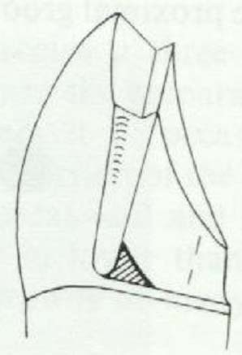

**Differences in the preparation of upper and lower posterior teeth**

**1-** The occlusal finishing line of the maxillary teeth terminate near the bucco-occlusal junction while in the lower teeth the finishing line is 1 mm. gingival to the lowest occlusal contact with the upper teeth because the buccal cusp in lower teeth is a functional cusp which should be covered by gold.

**2-** In the maxillary teeth there should be an offset, in the lower teeth there is no offset but there is a bucco-occlusal shoulder (more reduction).

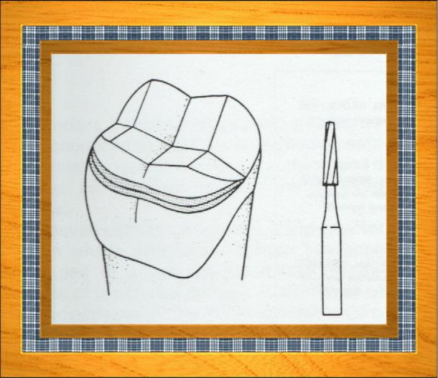

**Differences between anterior and posterior teeth preparation**

In the anterior teeth the retentive proximal groove should be parallel to the incisal 2/3 of the labial surface while in the posterior teeth it is parallel to long axis to get the longest groove for better retention of crown.

