**CROWN AND BRIDGE**

Lecture (7) Third class  Pontic

It is the suspended portion of the fixed partial denture (bridge) replacing the missing natural tooth or teeth and restoring its function.

The abutment tooth is the tooth that supports the bridge by retainer which connects to the pontic by connector, the retainer is either:

1- Major retainer (fixed by solder joint).

2-Minor retainer when the connection is not rigid (flexible) ex. Stress breaker.

Each part of the bridge whether the retainer or pontic is called a **unit**, example: 2 retainers and 1 pontic are called 3-unit bridge.

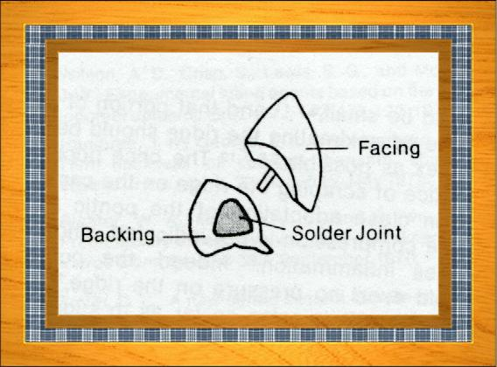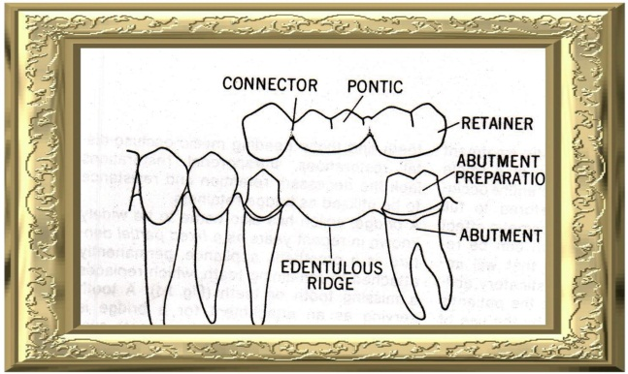

**Components of the pontic**:

In longitudinal section the pontic is divided into:

**1**- Metal backing.

**2**- Solder joint.

**3**- Facing.

**Materials used in pontic fabrication**

The pontic may be fabricated from casting metal or combination of metal and porcelain or acrylic facing. Usually full metal pontic is used for the posterior region while the combination of metal and facing (porcelain or acrylic) is used in anterior region for esthetic reason.

The glazed porcelain is more preferable than acrylic in pontic fabrication because acrylic is porous in nature and difficult in obtaining highly polished surface which leads to plaque accumulation and cause gingival inflammation.

**Requirements of the pontic**

1. 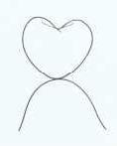The pontic must be hygienic so the patient can easily maintain good oral hygiene. The pontic must not cause any irritation to the underlying soft tissue by pressure or by food accumulation. Therefore, the contact of the pontic tissue surface with the underlying soft tissue should be **convex** to prevent entrapment of food under the pontic.

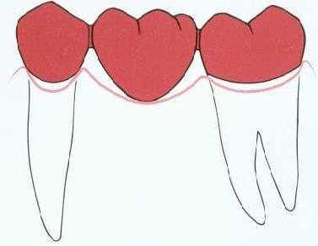

**2-** The contact area or solder joint should guard the interproximal area and the embrasure should be opened well to allow massage of the gingival tissue.

If the solder joint is too small there will be an increase interproximal space and possible food accumulation. The connector region would be weak and prone to fracture. If we have too wide contact area there will be impingement of the pontic on the interproximal gingival tissue.

**3-** The contour of the labial and lingual surfaces of the pontic must be proper and lie with the same line of contour of the adjacent teeth so it will allow protection of the underlying tissue

**4-** The pontic must restore the masticatory function of the tooth it replaces efficiently.

It is advisable to narrow the occlusal surface of pontic to reduce the stress that is going to be transmitted to the abutment tooth by occlusal forces.

**5-** The pontic must be strong enough to withstand the force to which it is subjected so mostly we use full metal in posterior region to withstand the heavy occlusal stress.

**6-** Pontic must provide good esthetic to improve the appearance of the patient.



**Pontic design**

**(1)Saddle pontic:**

The tissue surface of the pontic has the shape of the ridge. This design gives the illusion of a non-extracted tooth, which is accepted by the patient. This design is the most difficult to clean because there will be food accumulation between the tissue surface of the pontic and the alveolar ridge surface which will lead to tissue inflammation and failure of restoration. **This design shouldn’t be used at all.**

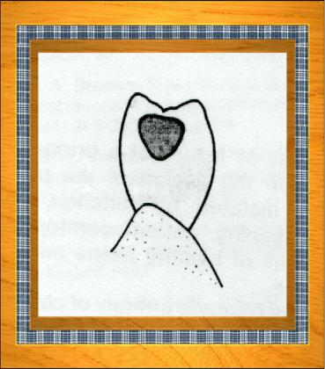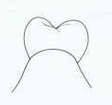

**2) Ridge lap pontic:**

This design gives the illusion of a non-extracted tooth. The tissue surface of the pontic is convex so there will be slight contact with the underlying soft tissue. This is the best design for all upper and lower teeth (the deciding factor of appearance zone depends on smile line).

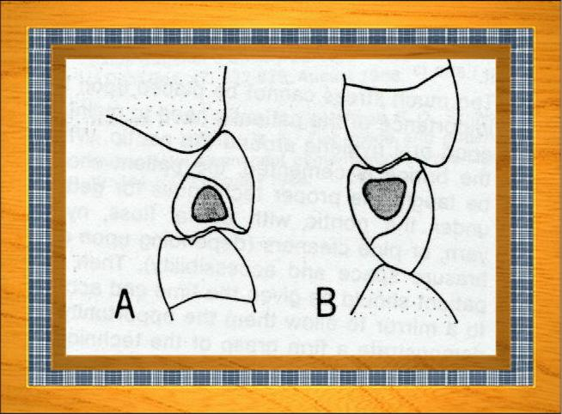

**3) Hygienic pontic (sanitary pontic):**

In this type there isn’t any contact between the ridge and the pontic. This is used when the missing tooth is located in the non-appearance zone (mostly the posterior teeth)

The pontic is completely made of metal and there is at least 3 mm space between the ridge and the pontic to facilitate proper cleaning of the region.

The pontic thickness should be at least 3mm to be strong enough to withstand the occlusal force.

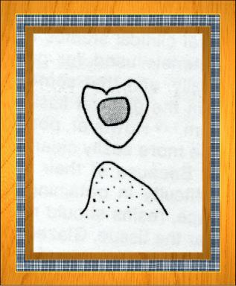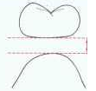

**4) Conical pontic: (spheroid or bullet)**

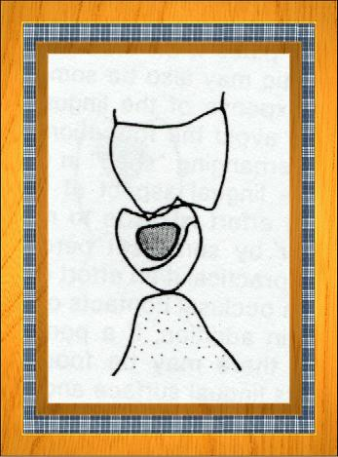It is used when the occlusal two thirds of the pontic lie in the appearance zone and this is mostly seen when we restore the lower incisors, premolars and sometimes molars because the gingival third is not seen (is not in the appearance zone) In this design there is no extension toward the labial surface.